|  |  |  |
| --- | --- | --- |
| **Safety Gadget for Child Safety Monitoring and**  **Notification**  **IBM NALAIYATHIRAN**      **Project Development –Delivery of Sprint 2**  **Creating Node –Red service and connect with IBM cloud and Web UI** | | |
|  | **TITLE** | IOT based child safety gadget for child safety monitoring and notification |
| **DOMAIN NAME** | INTERNET OF THINGS |
| **TEAM ID** | PNT2022TMID50609 |
| **TEAM LEADERNAME** | SELSHIA M |
| **TEAM MEMBER NAME** | BANUPRIYA K  SANDHIYA SUBASHREE M  SUBHASHINI G |
|  |  |
|  | |

**Creating Node-Red service:**

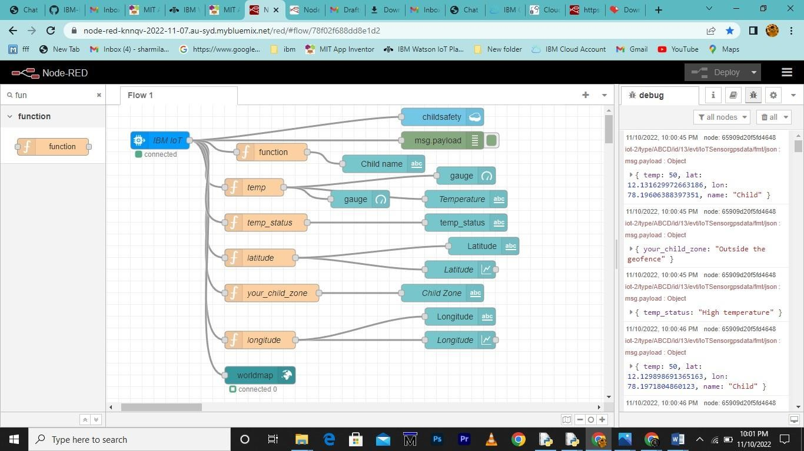

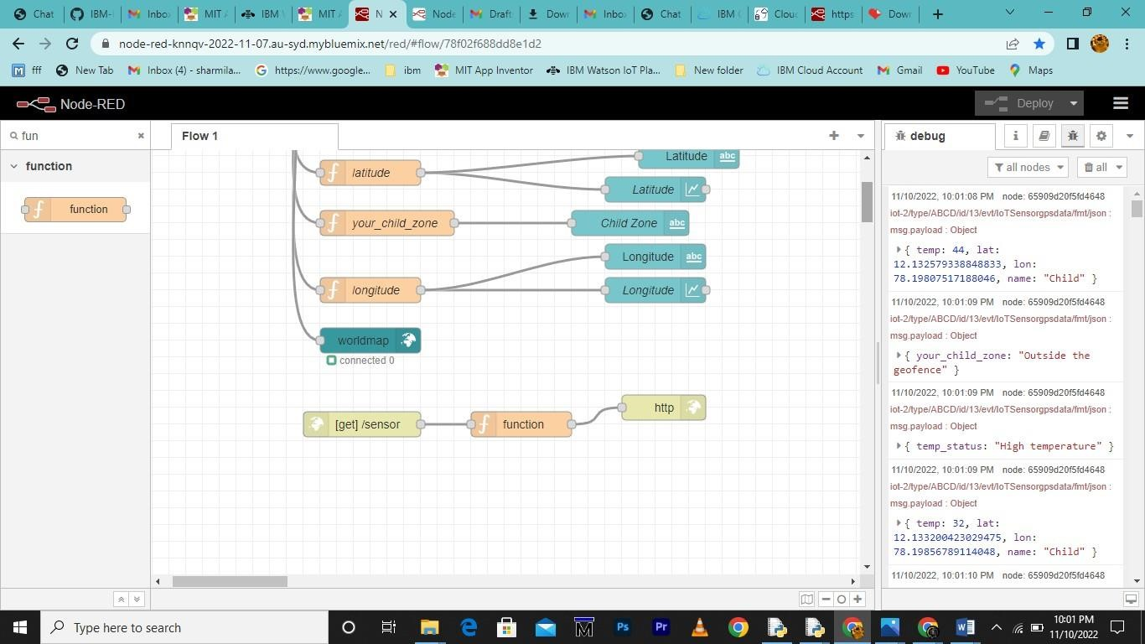

**Connecting with IBM Cloud:**

**Using IBM IOT node through API key**

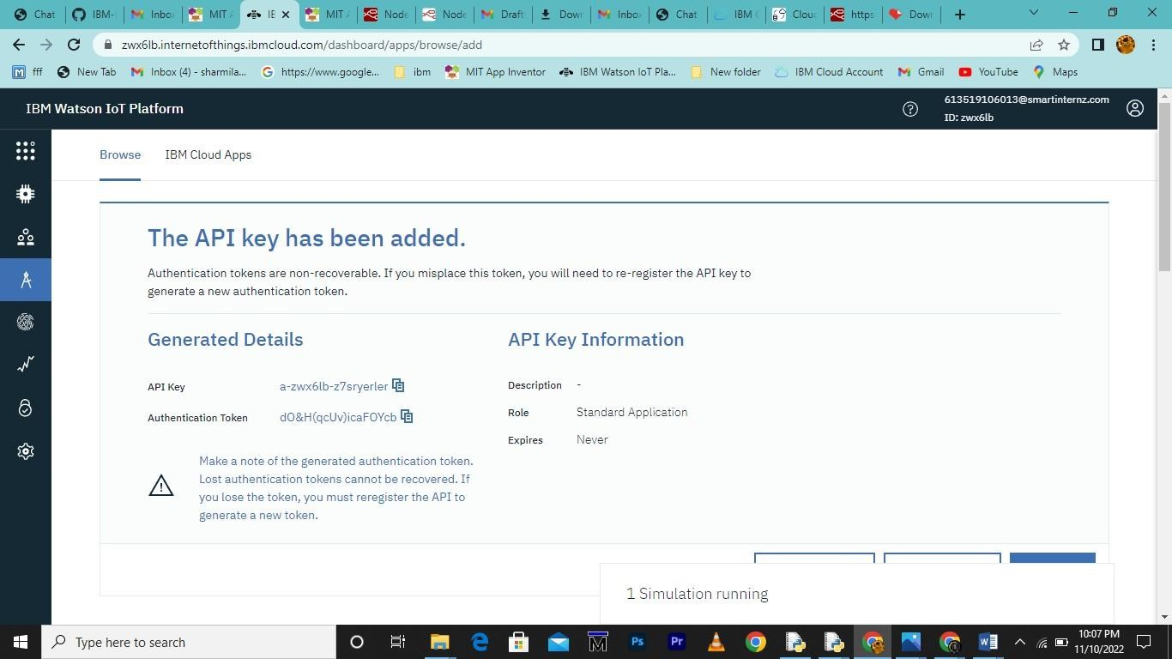

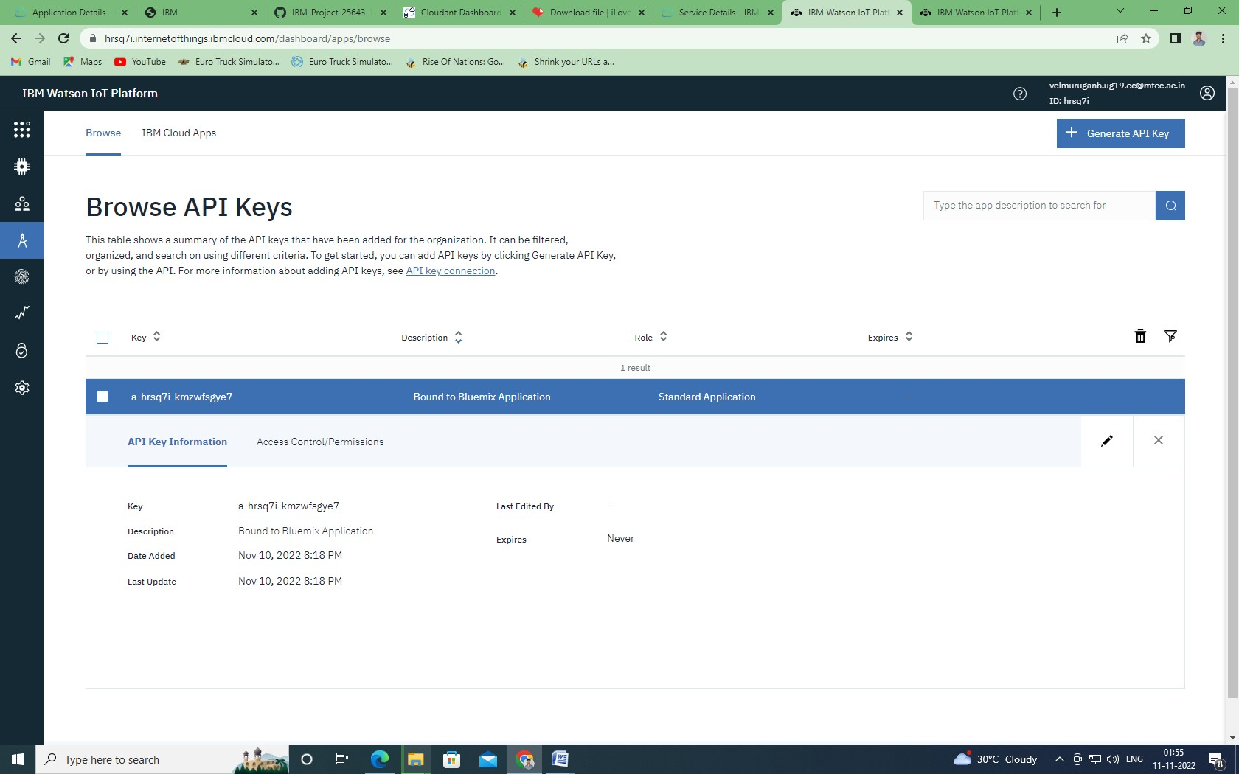

**Transfering values from Python Code:**

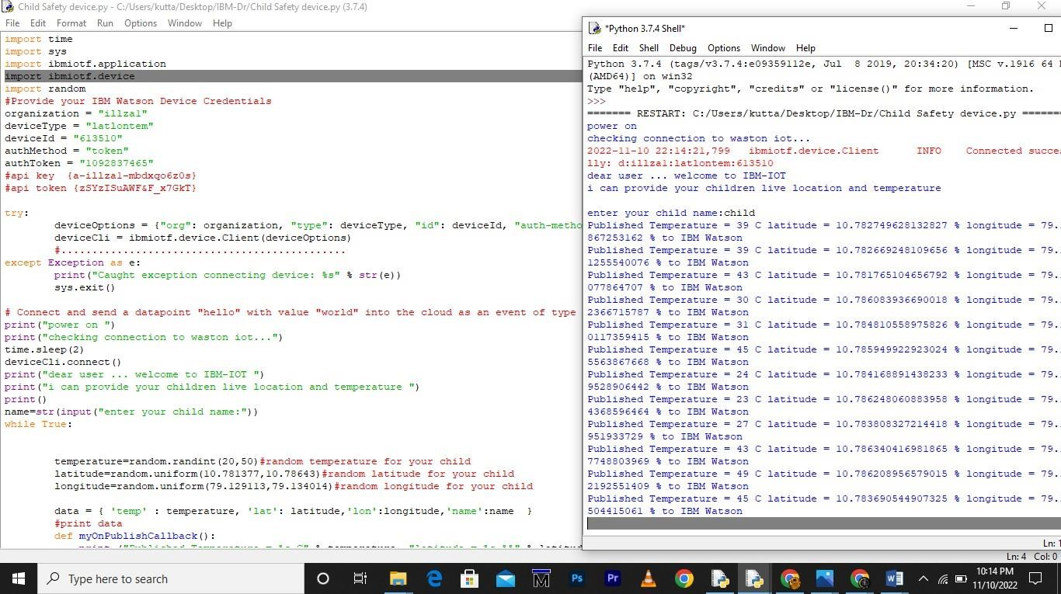

**Node-Red:**



**Node-Red Dashboard:**

